**AMPLITUTE TEST:**

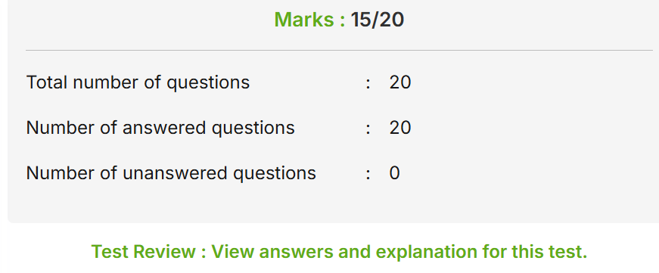

**YOUTUBE VIDEO**:

<https://youtube.com/shorts/o8_FT14EURQ?si=IEWDB54ScvlvPA_H>